

User Manual

# Table of Contents

|  |  |
| --- | --- |
| 1. Using WebAWDM Website | 2 – 8 |
| Home Page | 2 |
| Login | 3 – 5 |
| Gmail | 3 |
| NAU Mail | 4 – 5 |
| User Page | 6 – 7 |
| Initial View | 6 |
| SCREEN3 Tab | 6 |
| Archive Tab | 7 |
| Administrator Page | 7 |
| Initial View | 7 |
| Administrator Tab | 8 |
| II. Using WebAWDM SCREEN3 Program | 9 - 14 |
| Navigation Options | 10 |
| Form Object Types | 10 |
| File Archiving | 11 |
| Forms | 12 |
| Page Functionality | 12 |
| Sub Page Functionality | 12 |
| Visibility | 13 |
| Submit Action | 14 |
|  |  |

1. **Using WebAWDM Website**

**Home Page**

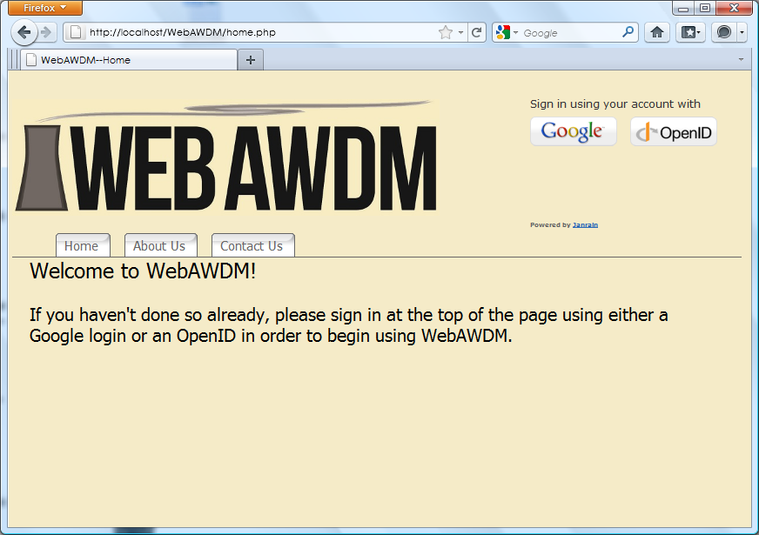

The welcome page to WebAWDM.

**Login: Gmail Account**

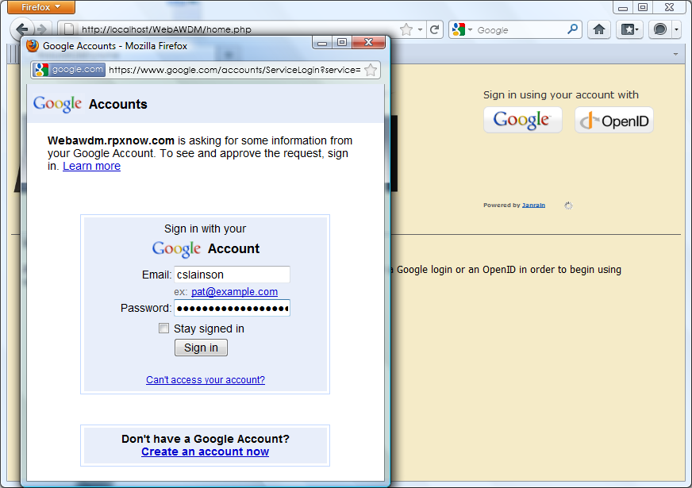

Users click the Google button to generate a pop-up window for login. The users Gmail username and

password should go in the pop-up window form. Successful login will take the user back to the home

-page, but with additional tabs (SCREEN3 & Archive).

**Login: NAU Account**

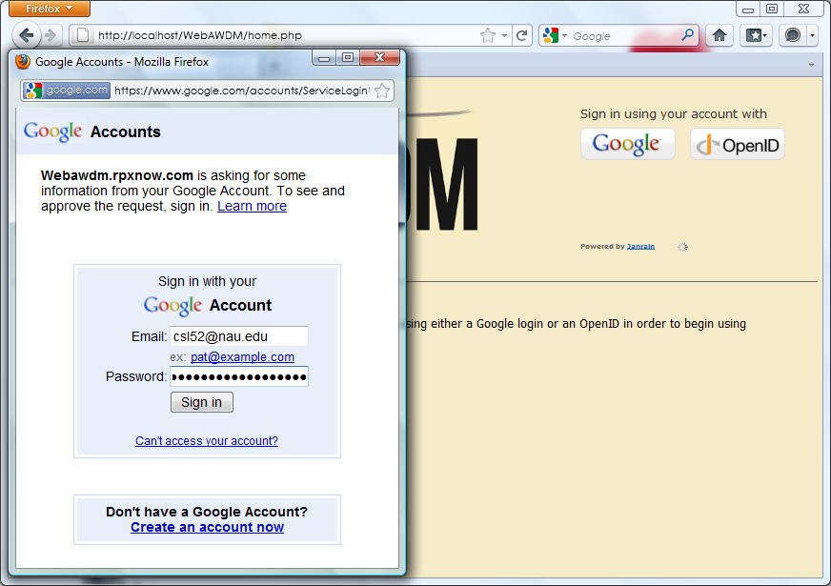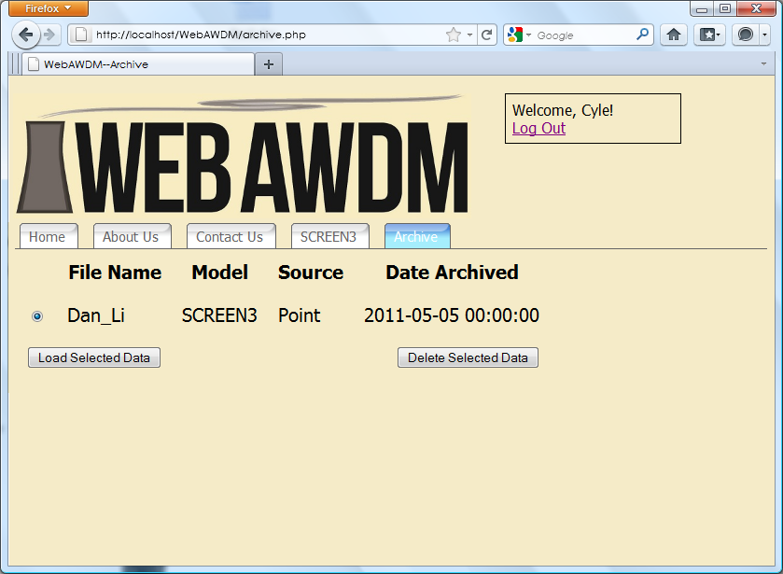

Users click the Google button to generate a pop-up window for login.The user’s full NAU mail username

and password should go in the pop-up window form. The result should be a redirect.

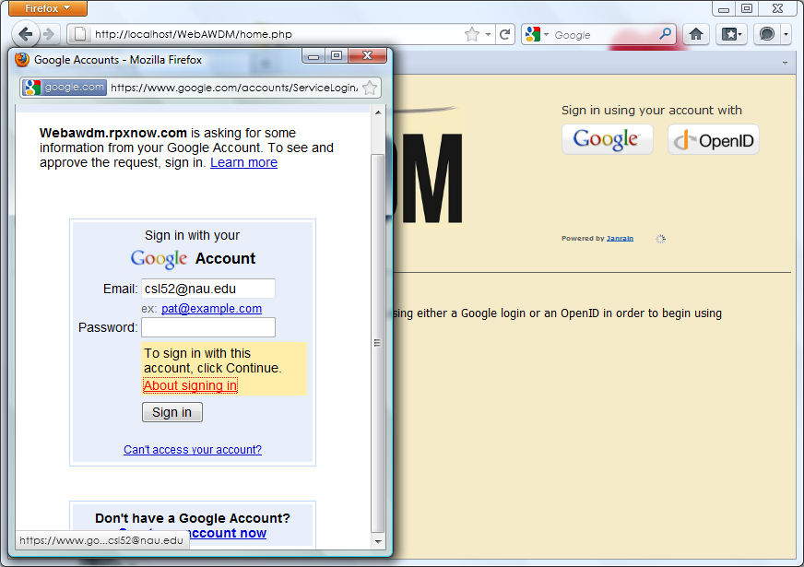

Click the ‘About signing in’ link, resulting in another redirect.

**Login: NAU Account (Cont)**

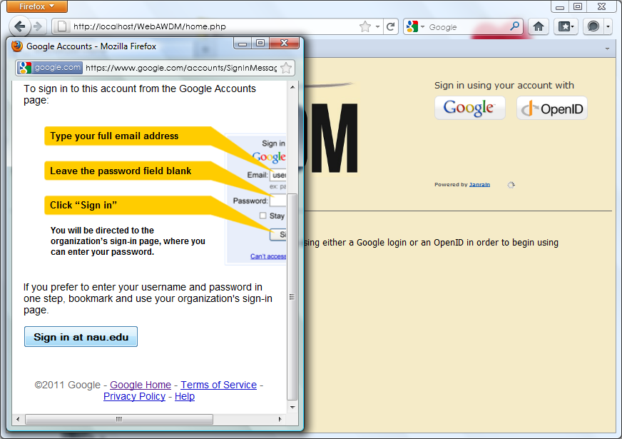

Scroll down to the bottom of this page. Click the ‘Sign in at nau.edu’ button.

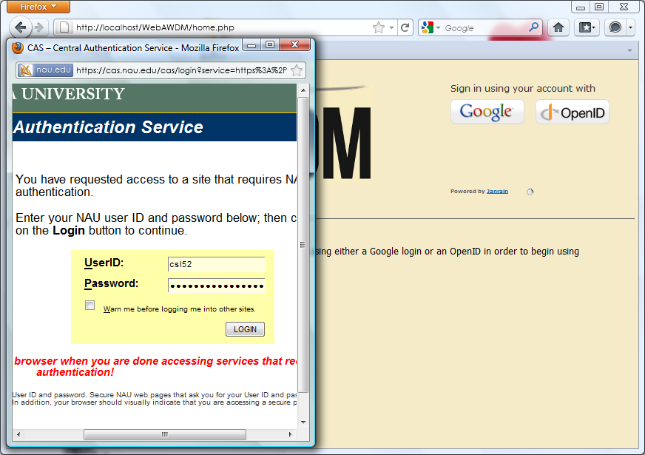

The NAU mail login screen should appear. Use the scrollbars to frame the login inputs. The users NAU username

and password should go in the pop-up window form. Successful login will take the user back to the homepage

additional tabs (SCREEN3 & Archive).

**User Page: Initial View**

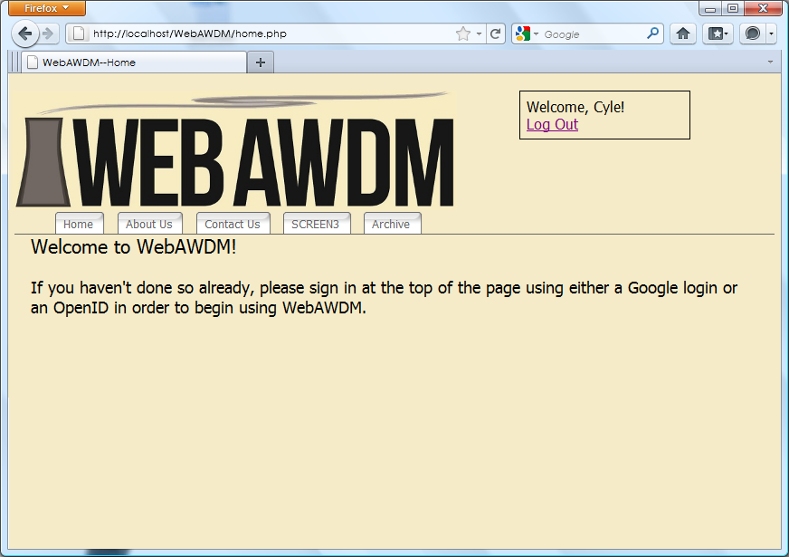

Once Logged in, this screen should appear giving the user the option to run SCREEN3 or navigate

the archive.

**User Page: SCREEN3 Tab**

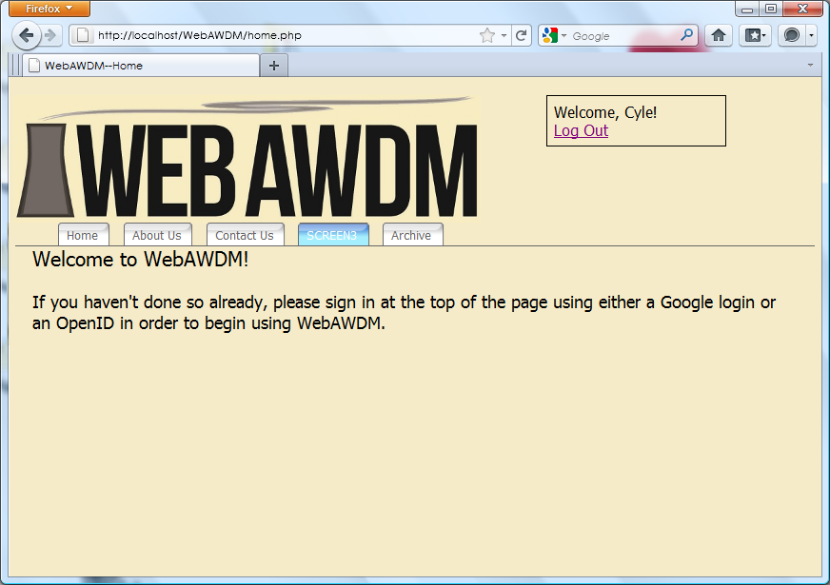

Click the SCREEN3 tab to be redirected to the SCREEN3 program

**User Page: Archive Tab**



Users have the option to load or delete data from their archive.

**Administrator Page: Initial View**

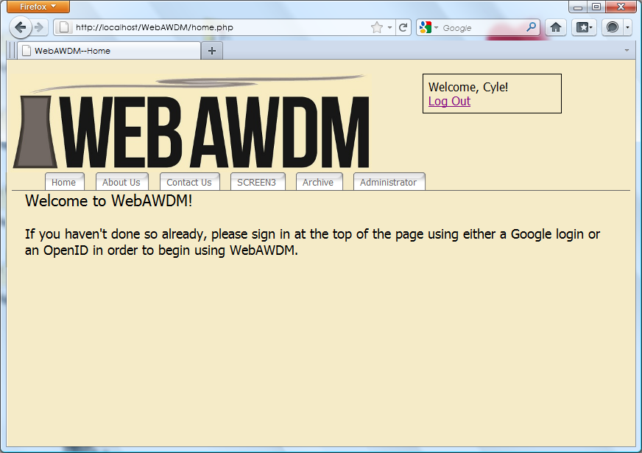

If an administrator, once logged in, this screen should appear giving the admin the option to run SCREEN3,

navigate the archive, or administration.

**Administrator Page: Administrator Tab**

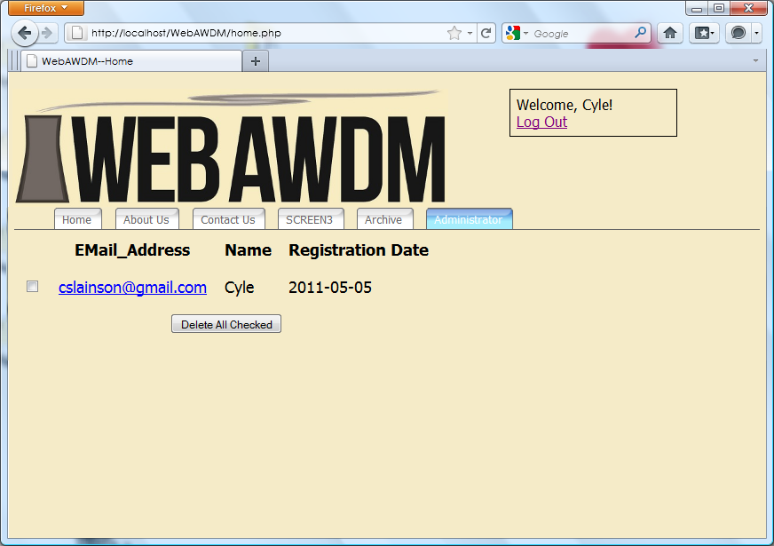

Admininistrators have the ability to view all normal users and delete them.

1. **Using WebAWDM SCREEN3 Program**

**Navigation Options**

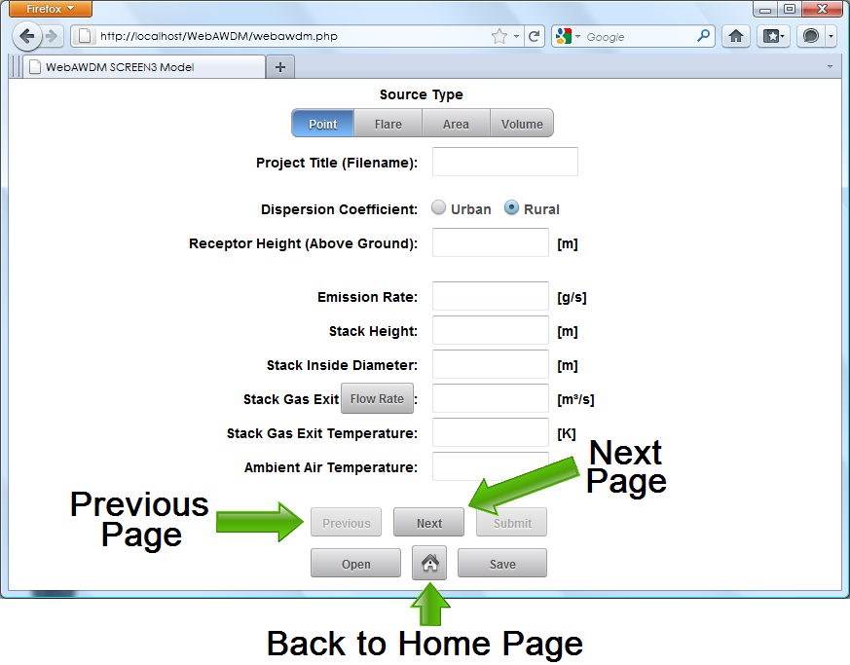

The Next and Previous buttons allow navigation of pages relative to the current page. Buttons are disabled

when the navigation option is not possible. The Home button sends the user back to the WebAWDM homepage.

**Form Object Types**

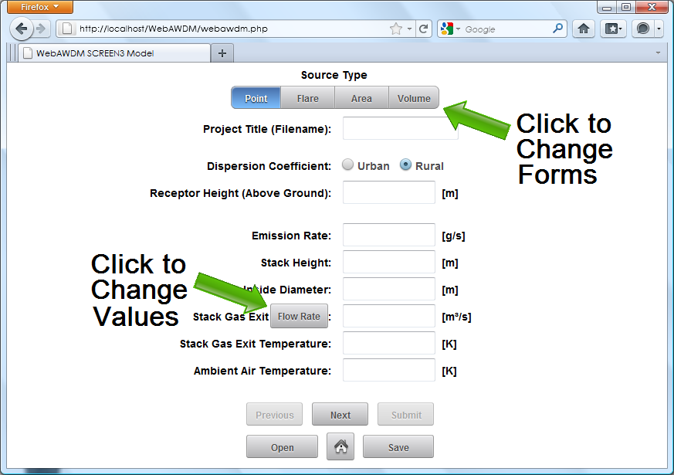

The segmented button bar on top determines the source type, changing the form to the appropriate forms.

Unit buttons when clicked change value, in order, through a list of values. Radio buttons, checkboxes and

input fields area also available to allow additional information to be collected

**File Archiving Options**

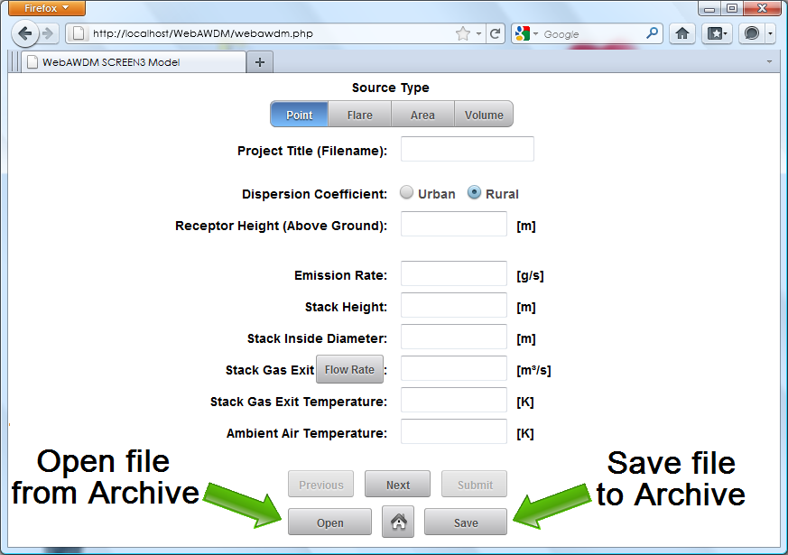

The Open button redirects to the user’s file archive page. The Save button archive all current information

to the users file archive.

**Archive Page**

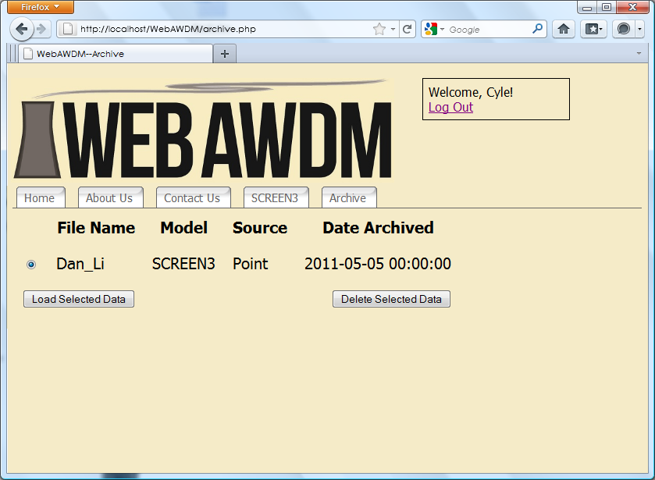

The archive page displays the user’s saved files, also provides the option to load or delete archived files

**Forms: Page Functionality**

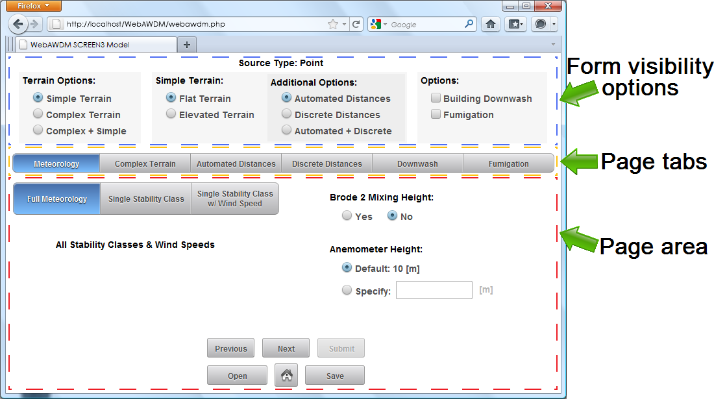

Page tabs change forms change the page area to the appropriate form, clicking the Previous or Next button

cycles through the page tabs in order. Form visibility options is a stationary menu, it changes/disables forms

that are both visible and not visible in the page area.

**Forms: Sub Page Functionality**

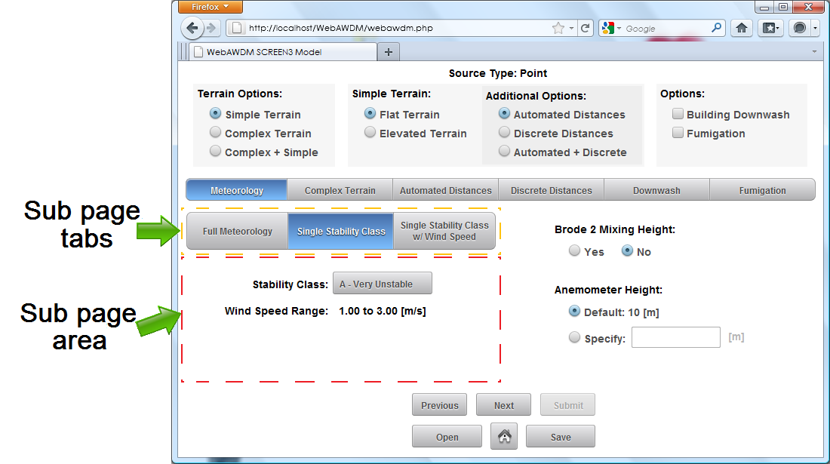

Sub pages are contained in regular pages. Sub page tabs change forms change the sub page area to

the appropriate form.

**Forms: Visibility Example**

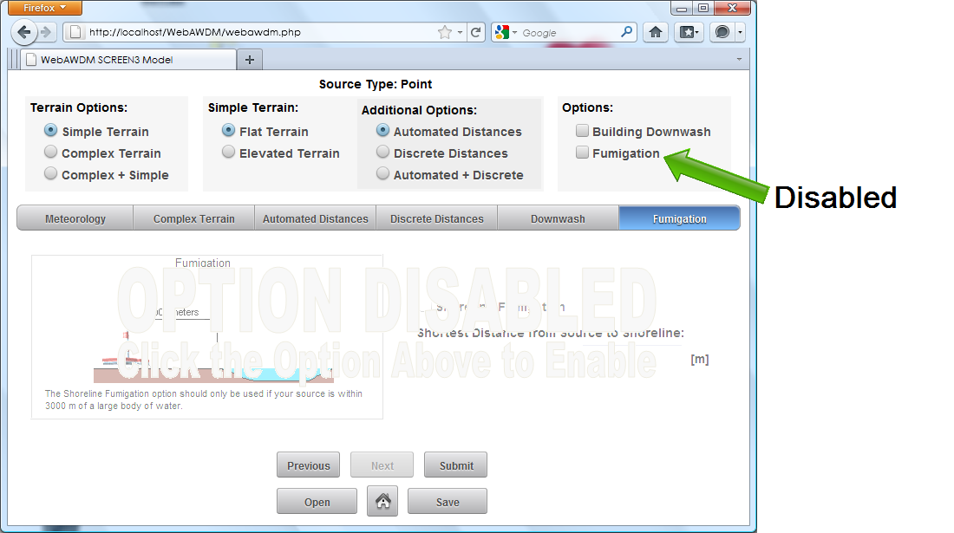

Example of the fumigation form being disabled.

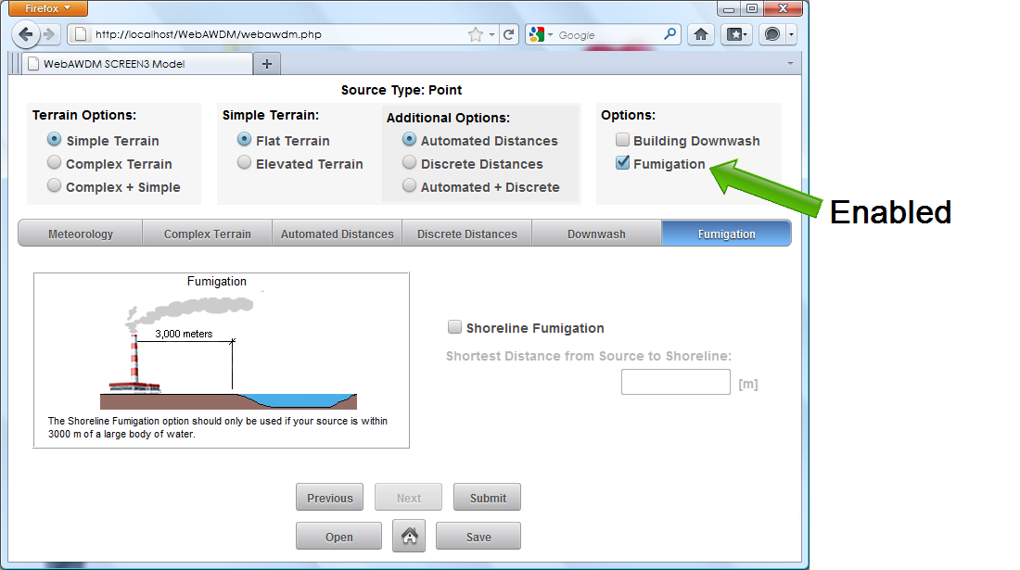

Example of the fumigation form being enabled.

**Submit Action**

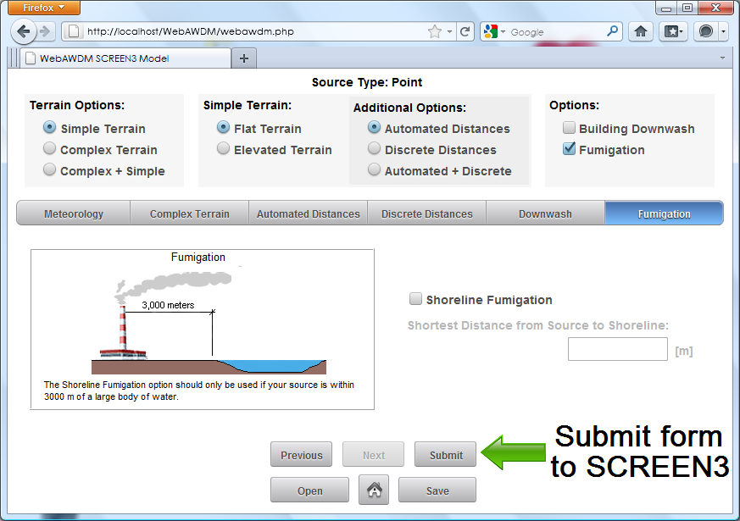

On the last form, the Submit button becomes enabled. Clicking the button submits the form to SCREEN3

generating an output file and graph, shown in a pop-up window.

**Submit Action Pop-up**

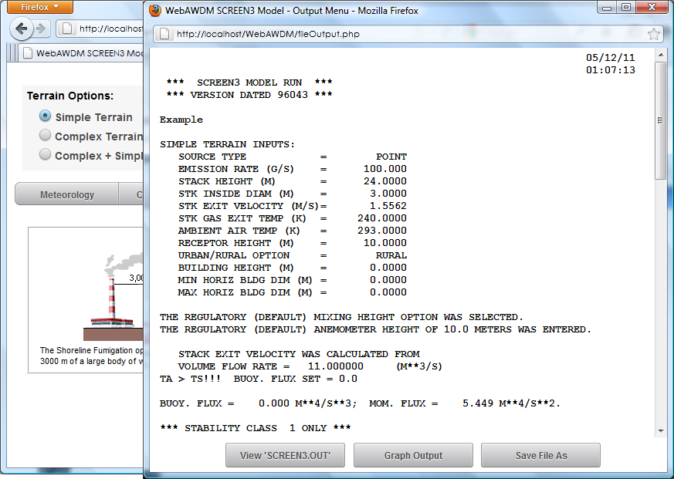

The pop-up window contains three buttons: View ‘SCREEN3.OUT, Graph Output, and Save File As. Clicking each

button reveals corresponding page in the scrollable sub page.